MBA 546 Case Report, Week 2
Topic: Alumni Messaging
Due date: September 10, 2023
Submitted by: Samyak Pratap Shah
Alumni Messaging

Executive Summary
Holmes University, a private institution located in the Midwest, offers both undergraduate and graduate programs to its students. Recently, the university decided to engage with its alumni by sending out postcards categorized into three types: Career, Research, and Sports. They aimed to reach both male and female alumni, including both undergraduates and graduates.
I was brought in as a consultant by Holmes University and tasked with surveying 367 alumni to determine which type of postcards would generate more engagement. To gather this information, I began by utilizing a pivot chart in Microsoft Excel. Furthermore, I employed SAS Studio to conduct a more in-depth analysis, specifically by performing a chi-square test.
The results of the tests revealed a correlation between the preferences of alumni and their respective categories. It became evident that female alumni showed a preference for career-related postcards, whereas male alumni, both undergraduate and graduate, were inclined towards either career or sports-themed postcards. Interestingly, undergraduate males exhibited a higher preference for sports-related postcards compared to other categories. On the graduate side, career-related postcards were more likely to be chosen by female alumni.

Introduction
I am employed as a consultant at Holmes University, and my assignment entails determining the most suitable postcard categories, namely Career, Sports, and Research, for both undergraduate and graduate alumni. To accomplish this, I will employ Excel and SAS for in-depth analysis. My goal is to ascertain whether postcard preferences are independent of the predefined categories or if they vary based on the gender or degree earned of the 367 university alumni surveyed.

Data
Sum of Frequency
Sex | Degree | Best Message | Total
Female | Graduate | Career | 33
 |  | Research | 12
 |  | Sports | 10
 | Graduate Total |  | 55
 | Undergraduate | Career | 47
 |  | Research | 31
 |  | Sports | 33
 | Undergraduate Total |  | 111
Female Total |  |  | 166
Male | Graduate | Career | 28
 |  | Research | 10
 |  | Sports | 28
 | Graduate Total |  | 66
 | Undergraduate | Career | 41
 |  | Research | 33
 |  | Sports | 61
 | Undergraduate Total |  | 135
Male Total |  |  | 201
Grand Total |  |  | 367

The provided table contains data collected from 367 alumni, showcasing their postcard preferences. These preferences are divided into three categories: Career, Research, and Sports. Among the alumni, there are 201 males (comprising 66 graduates and 135 undergraduates) and 166 females (comprising 55 graduates and 111 undergraduates), totaling 367 individuals. Additionally, the table was created using the Pivot-chart using Microsoft Excel. Furthermore, the accompanying bar chart was generated using Microsoft Excel's Bar Chart feature, offering a visual representation of the postcard choices.

The bar chart visually depicts the relationships between the alumni and their preferences for the three types of postcards. As indicated by the chart, the most frequent choices among undergraduate males and females are sports and career, respectively. Among graduate alumni, males seem to be open to either career or sports-themed postcards, while female graduates exhibit a preference for career-oriented postcards, like the undergraduates. In the case of undergraduate males, career and research follow sports postcards in terms of preference, with research being the least favored. Among undergraduate females, sports and research rank as the second and third preferences, while research and sports after career are the choices for female graduate alumni.

Analysis
To analyze the data, I utilized SAS Studio to perform a one-way chi-square test and conduct table analysis. Initially, my goal was to determine which postcards had a higher likelihood of being chosen and could potentially boost engagement. I also generated a chi-square table using the One-Way frequencies dialog. The chi-square test results indicated a chi-square value of 17.3678 and a p-value of 0.0002. Furthermore, this table provided statistical insights into the likelihood of alumni selecting each of the three categorized postcards. Given that the p-value is significantly smaller than the standard threshold of α=0.05, we can confidently reject the null hypothesis (H0), which proposed that the postcards were equally likely to be chosen. Instead, we opt not to reject the alternative hypothesis (Ha), indicating that the postcards were not equally likely to be selected.
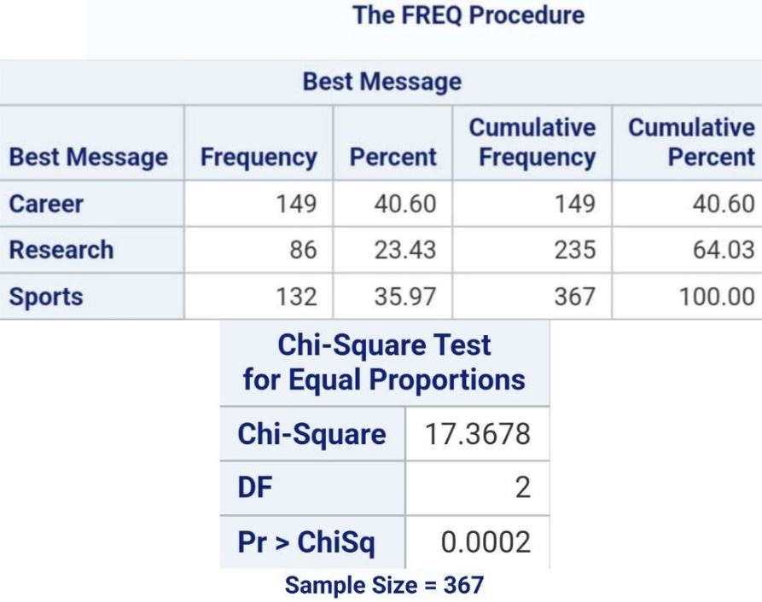
On to the table analysis, we pursued a chi-square test to examine the independence of variables. The objective here was to assess the relationship between postcard choices and gender using the chi-square test for independence. The outcome is presented in the subsequent table, which reveals a chi-square value of 13.6285 and a p-value of 0.0011. As the p-value is below the significance level of α=0.05, we can reject the null hypothesis. Consequently, we can conclude that there is a noteworthy correlation between the selection of postcards and sex of the alumni.
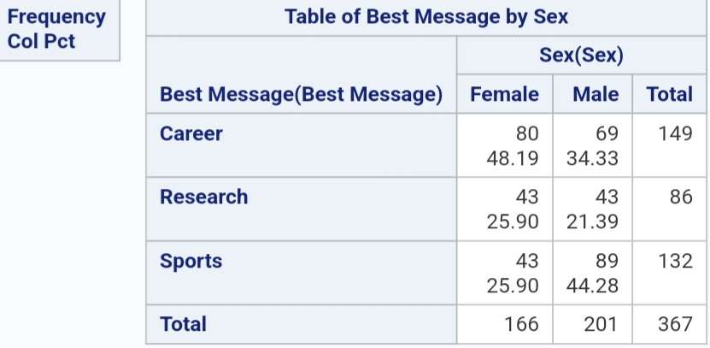
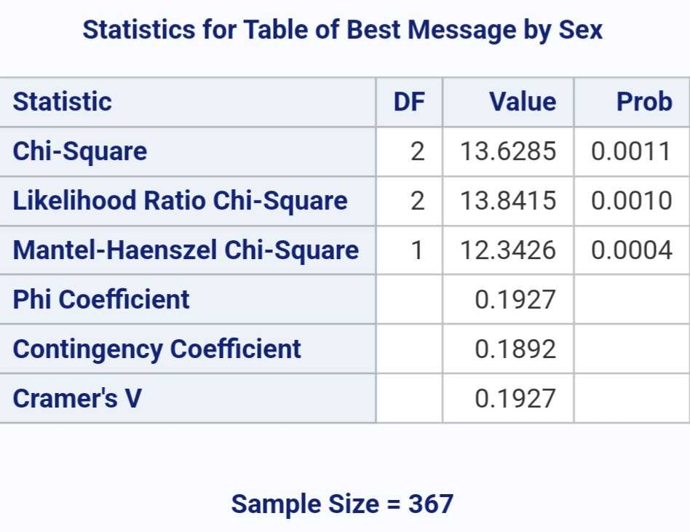
Similarly, I repeated the process once more conducted an analysis to explore postcard preferences in relation to the type of degree obtained. The resulting table indicates a chi-square value of 7.4153 and a p-value of 0.0241. Furthermore, as the p-value remains below the significance threshold of α=0.05, we have valid grounds to reject the null hypothesis. Thus, we can infer that a correlation exists between the choice of postcards and the type of degree earned and that they are not independent.
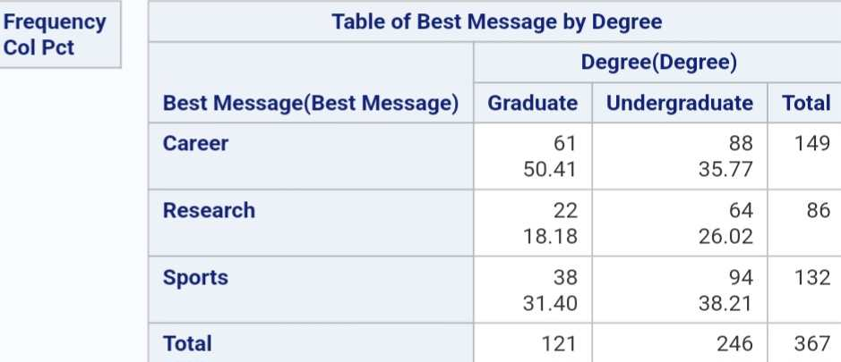

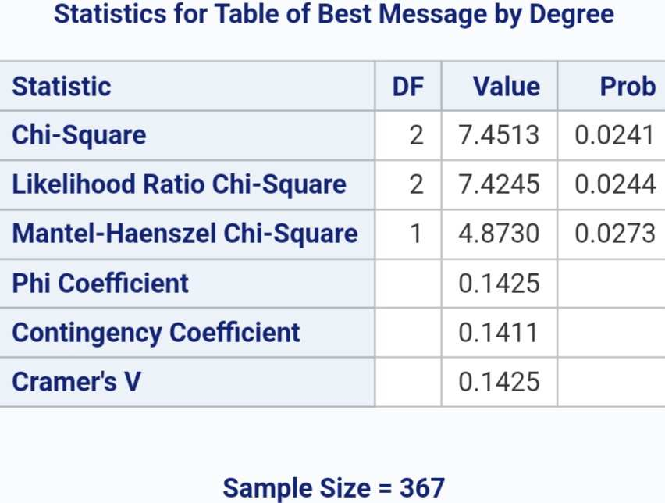

Recommendation/Conclusion
The analysis of the tests and their results indicates that alumni's selection of postcards, whether they opt for Sports, Career, or Research themes, is influenced by two key factors: their gender and the type of degree they earned from the university.
After examining the provided charts, here are my recommendations: For male graduate alumni, it is advisable to offer either sports-themed or career-themed postcards, as these options appear to be well-received. For male undergraduate alumni, sports-themed postcards seem to be the preferred choice. Conversely, female graduate alumni show a higher preference for career-themed postcards. However, when considering undergraduate alumni, the data suggests that all three postcard categories could be equally popular among both genders. To efficiently manage alumni engagement while accommodating diverse preferences, it would be cost-wise to offer all three categories of postcards to undergraduate alumni.

